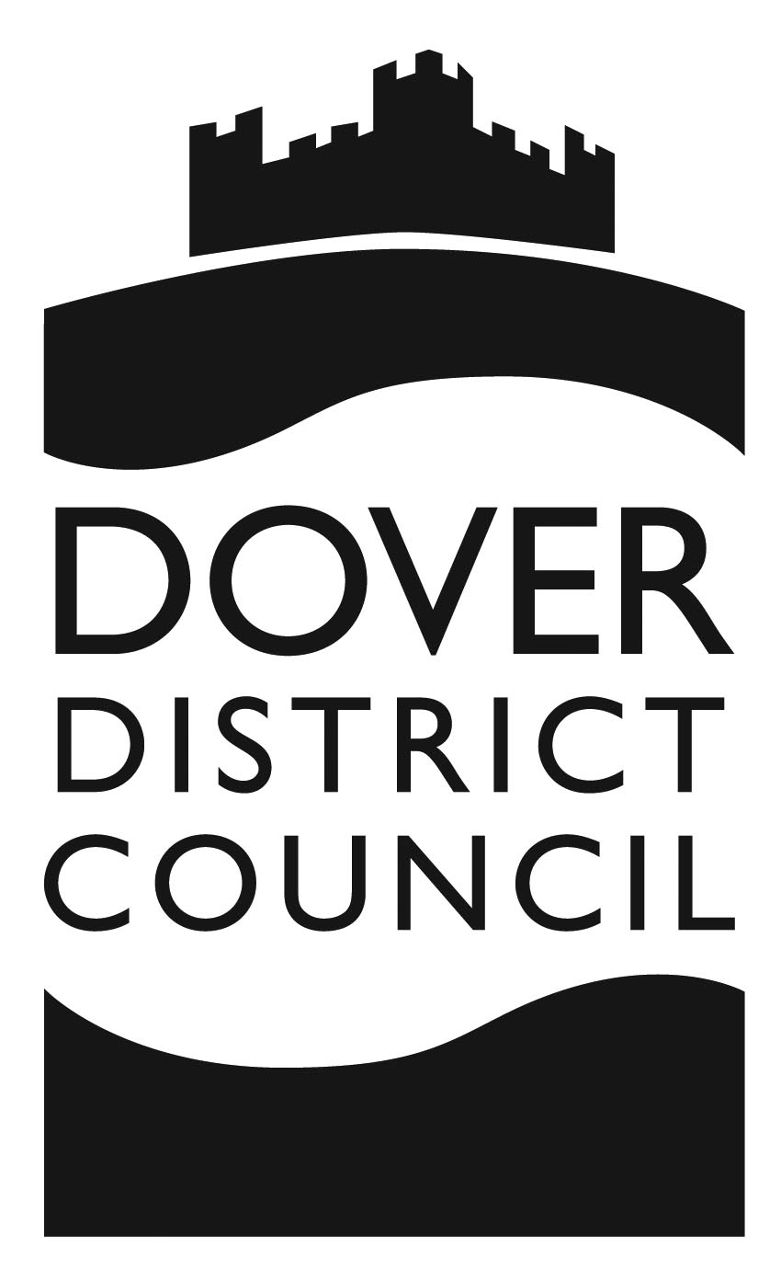 | Electoral Services  Dover District Council  White Cliffs Business Park  Dover  Kent  CT16 3PJ  Email: elections@dover.gov.uk  Website: www.dover.gov.uk
Linda Hedley  Ringwould with Kingsdown Parish Council  Ringwould Village Hall  Dover Road  Ringwould  Kent  CT14 8HE |  | Department: | Electoral Services
 |  | Direct Dial: | 01304 872344
 |  | Date: | 30 November 2023

Dear Linda Hedley

Co-option of Three Councillor's for the Parish of Ringwould with Kingsdown

The date for ten electors to request that an election be held for the parish of Ringwould with Kingsdown has now expired. You may now fill the vacancies by co-option.

The appointments should be made as soon as practicable and I would be grateful if you could notify me of the name and addresses of the new councillor's to enable me to update my records.

I would remind you of the need for all elected and co-opted councillors to complete and return to the Monitoring Officer (via the Clerk) a Disclosable Pecuniary Interest form within 28 days of their becoming a councillor. A copy of the Disclosable Pecuniary Interest registration form has been sent to all Clerks but further copies may be obtained from Democratic Services on 01304 872304 or by email at democraticservices@dover.gov.uk.

Yours sincerely

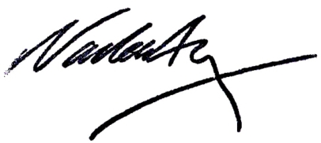

Nadeem Aziz
Returning Officer

